There are three types of loops
1.For loop 2. while loop 3.do while loop
1->FOR LOOP
Syntax
(i=initialization; condition; decrement/increment)
QUESTIONS:
- WAP to print “Hello World’ n times?
- WAP to print number from 1 to 100?
- WAP to print all odd/even numbers from 1 to 100?
- WAP to print the table of any given number from the user in the form e.g. 7*1=7?
- WAP to display AP series of 1,3,5,7,9,……n?
- WAP to display first 100 terns of AP series with common difference of 2?
- WAP to display AP 4,7,10,13,16….. up to n terms?
- WAP to display GP 1,2,4,8,16,…. up to n terms?
- WAP to display GP 3,12,28,…… up to n times?
10.Display this AP – 100,97,94,….. up to all terms which are positive? (with for loop and while loop)
11.Display this GP – 100,50,25,…… up to n terms?
NOTE :::
We can use different variable in for loop as well, for example
a = 100;
For( i=1; a>o; i++ );
BREAK;
B.12.WAP to display whether the given no is a prime no or not?
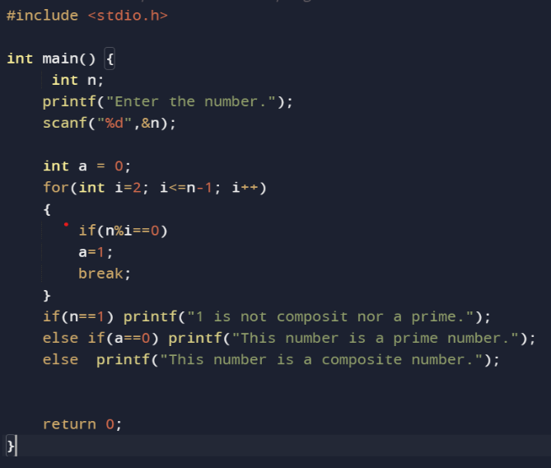
CONTNUE STATEMENT Skips that loop;
C.13. WAP to print odd/even numbers from 1 to 100 by using continue statements?
NOTE:
X++ use then increment. X-- use then decrement.
++x increment then use. –X decrement then use.
2WHILE LOOP;(when we don’t know the entering condition and leaving condition.)
Syntax;
Int()
While(condition)
{//code
}

